**Calculator**

In this project, HTML, CSS, and JavaScript is used to build a simple calculator web page. Users of this website will be able to conduct simple mathematical operations such addition, subtraction, multiplication, and division.

Three key parts will make up the project: HTML, CSS, and JavaScript. The framework of the webpage will be built using HTML, the styling will be done using CSS, and the calculations for the calculator will be handled by JavaScript.

The UI of the calculator will be straightforward and intuitive, featuring a display area, number buttons and operator buttons. The calculation's outcome will be displayed in the display area. Numbers will be entered using the number buttons.

**Html code(main page)**

<!DOCTYPE html>

<html lang="en">

<head>

<meta charset="UTF-8" />

<meta http-equiv="X-UA-Compatible" content="IE=edge" />

<meta name="viewport" content="width=device-width, initial-scale=1.0" />

<link rel="stylesheet" href="style.css" />

<link rel="stylesheet" href="https://cdnjs.cloudflare.com/ajax/libs/font-awesome/6.4.0/css/all.min.css"/>

<title>Calculator</title>

</head>

<body>

<main>

<section>

<header>

<a style="float:left;" href="#" class="logo"><i class="fa-duotone fa-calculator-simple"></i>Cal-C (calculations made simple)</a>

<div class="about">

<nav>

<div class="navi"><a style="float:left;" href="#">Home</a></div>

<div class="navi1"><a style="float:left;" href=#about>About Us</a></div>

<div class ="navi2"><a href="terms.html">terms and conditions</a></div>

</nav>

</div>

</header>

</section>

<section>

<div class="container">

<div class="calculator">

<input type="text" id="inputBox" placeholder="0" />

<div>

<button class="button operator">AC</button>

<button class="button operator">DEL</button>

<button class="button operator">%</button>

<button class="button operator">/</button>

</div>

<div>

<button class="button">7</button>

<button class="button">8</button>

<button class="button">9</button>

<button class="button operator">*</button>

</div>

<div>

<button class="button">4</button>

<button class="button">5</button>

<button class="button">6</button>

<button class="button operator">-</button>

</div>

<div>

<button class="button">1</button>

<button class="button">2</button>

<button class="button">3</button>

<button class="button operator">+</button>

</div>

<div>

<button class="button">00</button>

<button class="button">0</button>

<button class="button">.</button>

<button class="button equalBtn">=</button>

</div>

</div>

</div>

</section>

<article id="about">

<fieldset>

<legend>About us</legend>

<p>Welcome to our arithmetic calculator website! We are a team of dedicated developers and mathematicians who believe that everyone should have access to a reliable and easy-to-use calculator for their daily arithmetic needs.

Our website is designed to provide you with the best possible calculator experience. We understand that sometimes you need to perform quick calculations on the go, and our calculator is perfect for that. It's fast, accurate, and easy to use, making it the perfect tool for students, professionals, and anyone who needs to crunch numbers on a regular basis.

At our website, we are committed to providing you with a seamless and enjoyable experience. We understand that math can be intimidating for some people, and that's why we have designed our calculator to be intuitive and user-friendly. We believe that everyone should have access to the tools they need to succeed, and our calculator is just one way that we are working to make that a reality.

</p>

</fieldset>

</main>

<footer>

<p>Disclaimer:The information provided by the calculator is for educational and informational purposes only and should not

be used as a substitute for professional advice. We make no representations or warranties about the completeness,

accuracy, reliability, suitability or availability of the calculator.</p>

</footer>

<script src="script.js"></script>

</body>

</html>

**CSS Code**

@import url('https://fonts.googleapis.com/css2?family=Poppins:wght@500&display=swap');

*{

margin: 0;

padding: 0;

box-sizing: border-box;

font-family: 'Poppins', sans-serif;

}

body{

width: 100%;

height: 100vh;

display: flex;

justify-content: center;

align-items: center;

background: linear-gradient(45deg, #0e0e0e, #16161a);

flex-direction: column;

}

header{

position: fixed;

top:0;left: 0;right:0;

background-color: #3fe5a3;

padding: 1.3%;

align-items: end;

}

.logo {

color:#161939;

font-size: medium;

}

.logo i{

color: #161f39;

}

.calculator{

border: 0px solid #717377;

padding: 20px;

border-radius: 16px;

width: 41%;

background: rgb(10, 10, 10);

box-shadow: 0px 3px 15px rgba(113, 115, 119, 0.5);

margin-top: 2%;

}

input{

width: 320px;

border: auto;

border-radius: 20px;

padding: 24px;

margin: 10px;

background: transparent;

box-shadow: 0px 3px 15px rgbs(84, 84, 84, 0.1);

font-size: 50px;

text-align: right;

cursor: pointer;

color: #ffffff;

}

input::placeholder{

color: #ffffff;

}

button{

border: none;

width: 60px;

height: 60px;

margin: 10px;

border-radius: 50%;

background: transparent;

color: #fb7c14;

font-size: 20px;

box-shadow: -8px -8px 15px rgba(255, 255, 255, 0.1);

cursor: pointer;

}

.equalBtn{

background-color: #fb7c14;

color:#ffffff

}

.operator{

color: #00e1ff;

}

button:hover{

background-color: #292929;

}

.logo{

font-size:large;

text-decoration: none;

color: #0f1558;

}

header.logo i{

color:#0f1558;

}

footer{

margin-top: 1px;

color: #ffffff;

padding: 1%;

text-align-last:auto;

}

.about{

border: 0px solid white;

color: #ffffff;

height: 20px;

width:80%;

margin-left:50%;

}

#about{

color: #ffffff;

}

#terms{

color:#ffffff

}

.container{

border: 0px solid white;

margin-top: 45%;

margin-left: 40%;

margin-bottom: 10%;

}

.navi{

float:left;

margin-left: 300px;

text-decoration: none;

}

.navi1{

float:left;

margin-left: 60px;

margin-top: 0px;

text-decoration: none;

}

.navi2{

float:left;

margin-left:50px;

text-decoration: none;

}

legend{

text-align: center;

}

fieldset{

margin-top:75px;

margin-left: 15%;

margin-bottom: 8%;

margin-right: 15%;

}

p{

padding-top: 10px;

padding-left: 10px;

padding-bottom: 10px;

padding-right: 10px;}

**Javascript Code**

let input = document.getElementById('inputBox');

let buttons = document.querySelectorAll('button');

let string = "";

let arr = Array.from(buttons);

arr.forEach(button => {

button.addEventListener('click', (e) =>{

if(e.target.innerHTML == '='){

string = eval(string);

input.value = string; }

else if(e.target.innerHTML == 'AC'){

string = "";

input.value = string; }

else if(e.target.innerHTML == 'DEL'){

string = string.substring(0, string.length-1);

input.value = string; }

else{

string += e.target.innerHTML;

input.value = string; }

})

})

**CALCULATOR:**

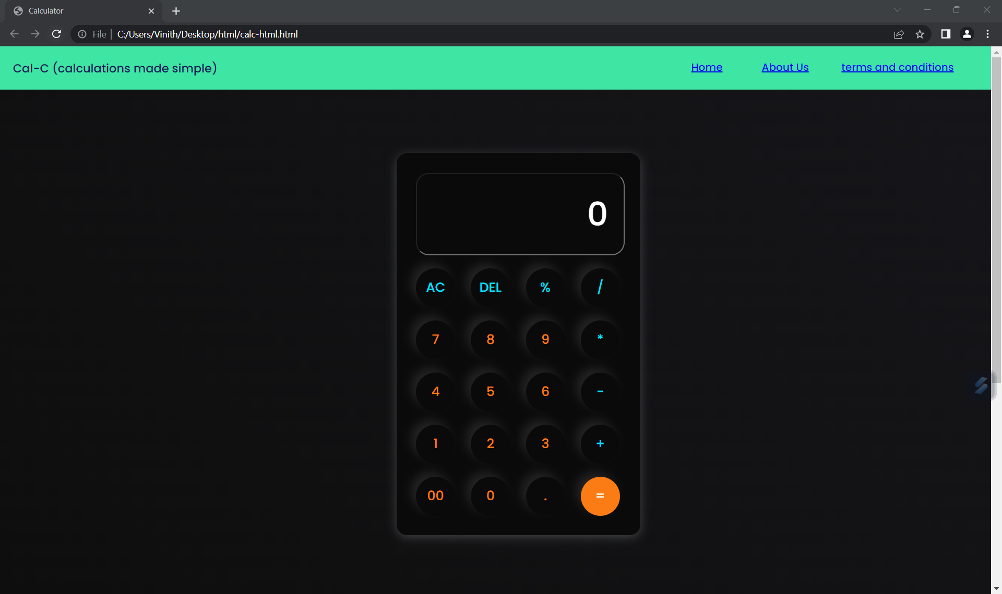**EXPRESSION:**

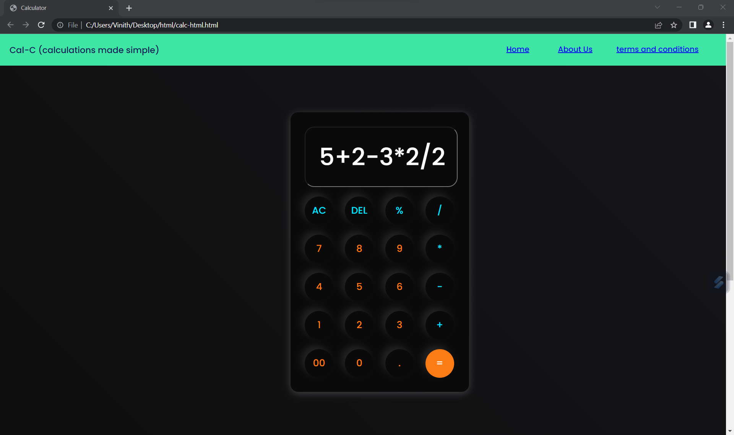

**RESULT:**

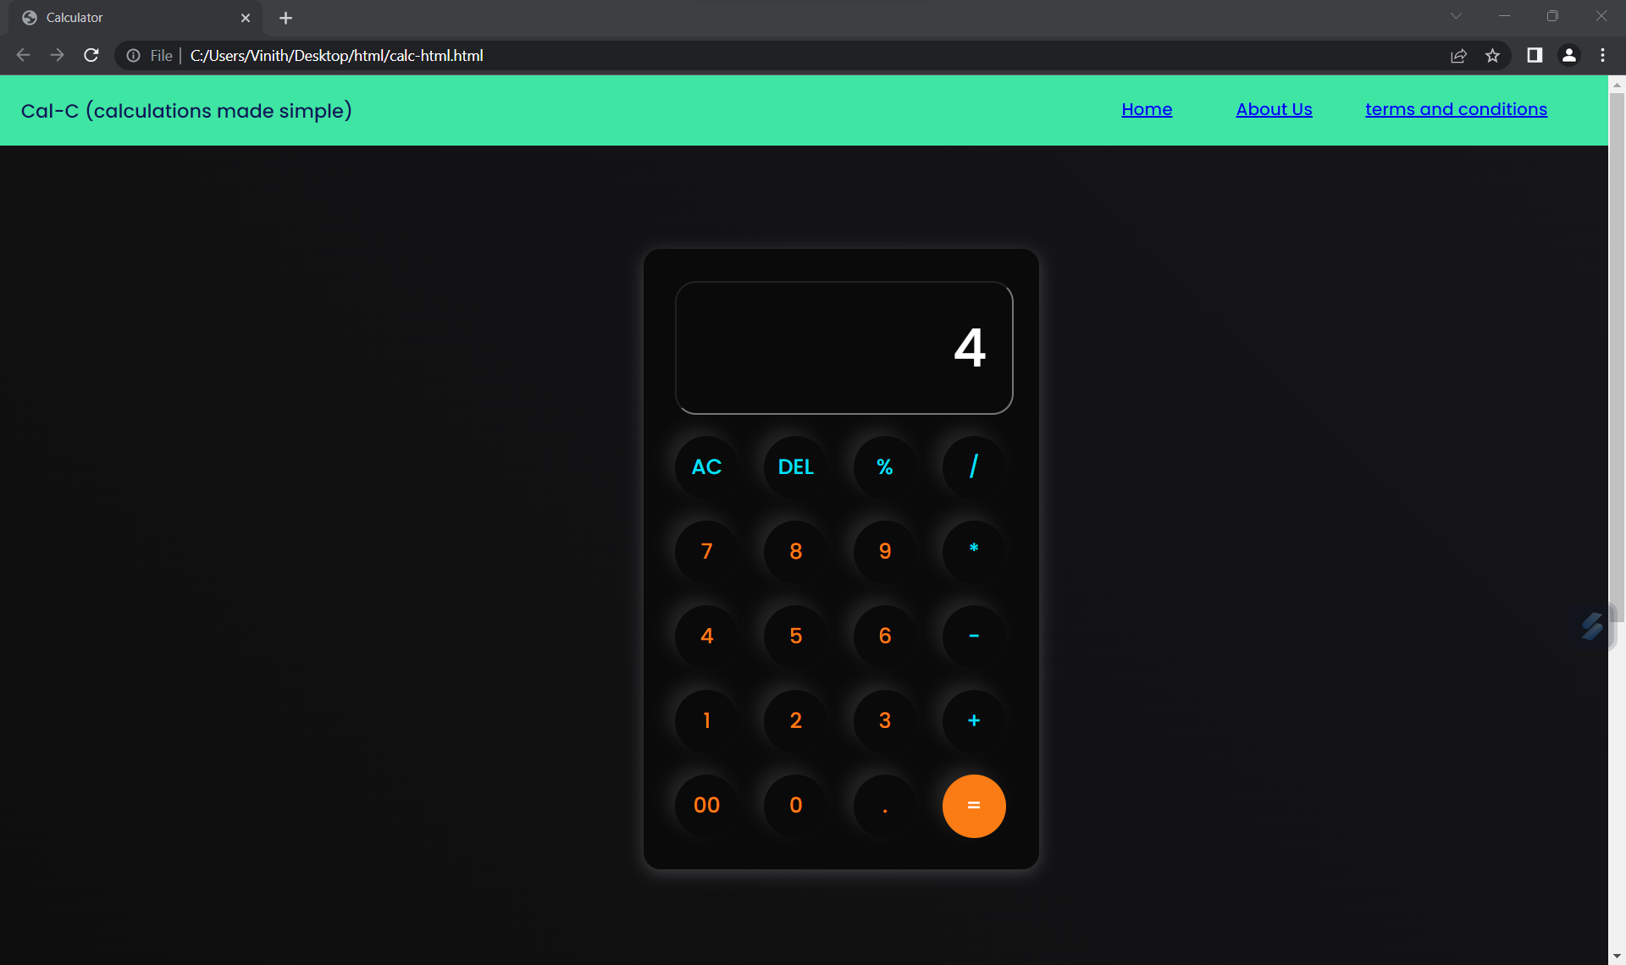

**ABOUT US AND DISCLAIMER:**

